Steps to update the KLN94 database into a KLN94 Database card through ImageMate.
- Start GpsLoader application.
- Select “Update GPS → Database” from the menu and then selects a KLN 94 database. The following dialog will be displayed.

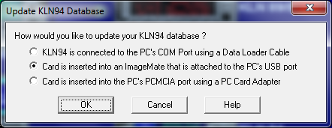

- Select “Card is inserted into an ImageMate that is attached to the PC’s USB port” option and click “OK”. The following dialog will be displayed.

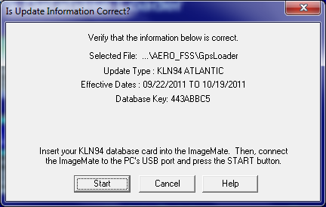

- Click “Start”. If the ImageMate is not connected OR if the ImageMate is connected but not detected by the Operating System, the following error message will be displayed.

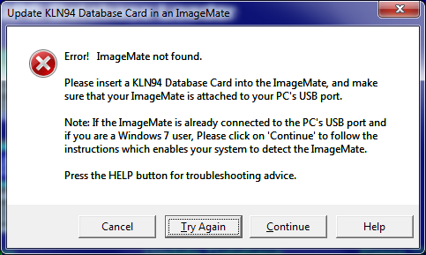

- If the ImageMate is not connected, please connect and click “Try Again”.
If the ImageMate is already connected click “Continue” and the following message will be displayed.

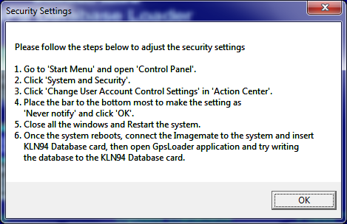

- If the ImageMate is successfully detected but if the KLN94 Database card is not inserted into the ImageMate, the following message will be displayed.
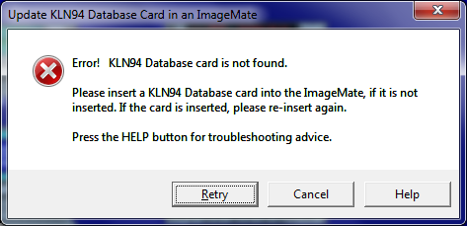

- If the ImageMate is successfully detected but if the KLN94 Database card is not detected yet, the following message will be displayed.
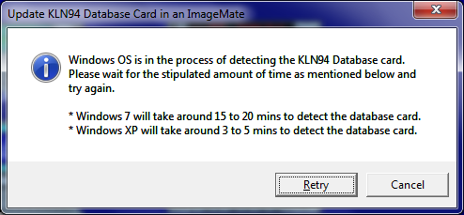

- If the ImageMate is successfully detected and if the KLN94 Database card is also detected, the following message will be displayed.
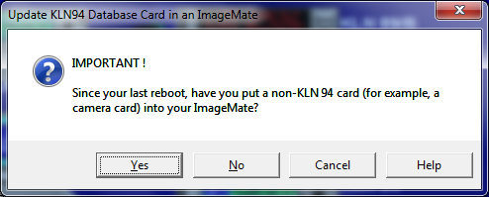
  - If you click “Yes” the following message will be displayed.
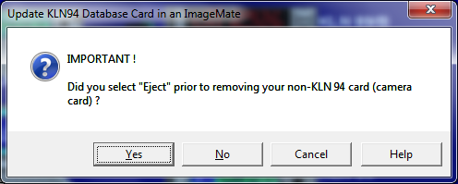

    - If you click “Yes” the writing process given below in the step 9 starts.
    - If you click “No” the following message will be displayed.

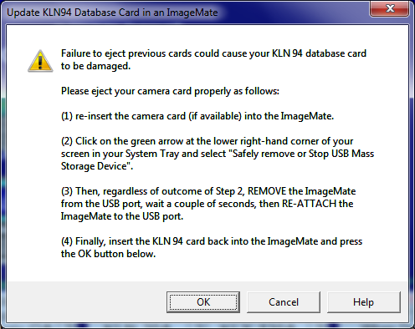

If you click “OK” the writing process mentioned in step 9 starts.
  - If you click “No” writing process mentioned in step 9 starts.

- Writing process.
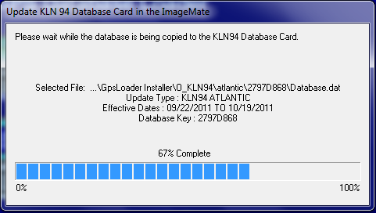
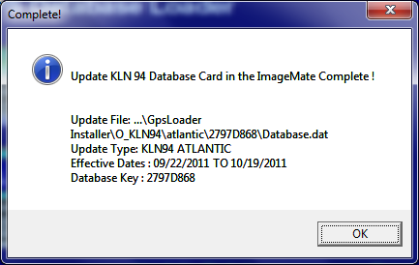
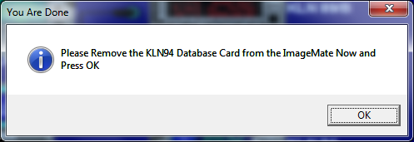

General errors
- If the Key in Database.dat and the key in your Database card is not matched, the following message will be displayed.
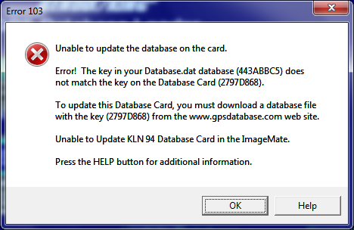
- If the ImageMate is disconnected when the writing process is in progress, the following message will be displayed.
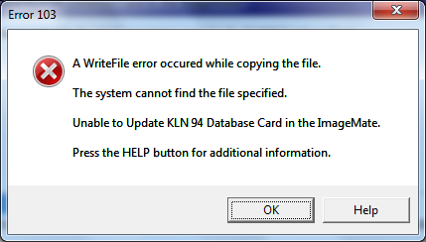
On “OK” the below message will be displayed.
